**DSSAT Code Details:**

**Author:** Rohit Kumar Malik

**Contact:** [**rkmalik1100@gmail.com**](mailto:rkmalik1100@gmail.com)

**Web URL: sites.google.com/site/rkmalik1104/**

**University Of Florida, Department of Computer and Information Science and Engineering**

1. Following is the code responsible to create a copy weather file at WeatherFileSystem.java into the DSSAT Installation Folder.



So it will generate the same copy in the C:\installations\DSSAT46\Weather\TCTC1602.WTH folder. Earlier it was copied at two locations right now we are just generating in only in data folder.

1. Following is the code responsible to create a JSON file that is used to create a PTX File. This code takes the Weather file .WTH and converts that into the JSON file. Which is then passed as input to the translator-dssat Jar library. This library takes the JSON input and converts that into a PTX file.

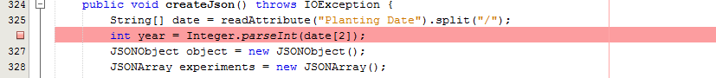

1. **PTX file creation:**
2. Where should we create all the Files?

As per my proposal to Jin, We should keep all the generated file at one place that is data folder. So that it is easy to access the file and the user is well informed where the file is located. In addition to this, I have provided a dialog box, so that user is informed when a file is created.

Following is the location of the files to save.

C:\Users\rohit\Downloads\rohit\dssat\data

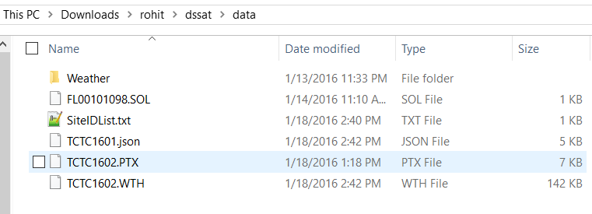

1. **Proposal To implement a Message Window and get rid of all the Dialog boxes from the application. This will track all the message in the same window. This will be a list box.**
2. **Where is the Sample PTX File**

For reference check following file

C:\Users\rohit\Downloads\a_netbeans_workspace\New_2DCSM_Input_Files.chm

C:\Users\rohit\Downloads\a_netbeans_workspace\UFRT1113.PTX

C:\Users\rohit\Downloads\a_netbeans_workspace\SampleXFileWhatINeedToCreate.PTX

C:\Users\rohit\Downloads\a_netbeans_workspace\process_initial.php

C:\Users\rohit\Downloads\a_netbeans_workspace\Dssat_Json_ICASA_Mapping.xlsm

Other Reference

Dropbox\Standard_XFile

1. What Validation is required in Irrigation Table.

Validation is Added in DSSAT

Bed Width